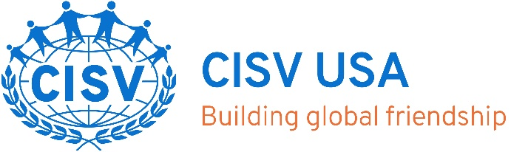

Youth Delegate Chapter Endorsement Form

Delegate Name:
The youth is applying for:
Seminar Camp (Peace education camp program for 16-17 olds)
If selected, the youth applicant will represent both the United States and their own area in an international setting. The CISV USA Seminar Committee requests your help in identifying applicants who exhibit leadership qualities and can represent their own culture successfully.
This form must be completed and returned no later than January 1.
Please email the completed form to:
Seminar Camp Committee and Chair (seminar@cisvusa.org AND cisvusa@cisvusa.org)

Name of chapter member completing this reference form:
Role in the chapter: _____________________________
Home/Cell Phone: E-mail Address: ___________
Capacity in which you know the youth applicant:
Length of time you have known the youth applicant: _________________
Please check all traits in the list below that you consider to be characteristic of the youth applicant. Then circle or highlight at least five adjectives you feel describe the youth applicant’s greatest strengths.

☐mature ☐independent ☐responsible ☐expressive ☐accepting ☐discerning☐shows initiative
☐ optimistic ☐pessimistic ☐responsive ☐cooperative ☐cautious☐ curious ☐attentive☐practical ☐helpful ☐participates ☐needs coaxing ☐caring ☐spontaneous ☐ reticent ☐open-minded ☐respects adults ☐respects peers ☐follower ☐leader ☐team player ☐fair-minded☐organized ☐dependent ☐creative ☐quiet ☐ secure☐vivacious ☐ sensitive ☐forgetful ☐introspective ☐friendly ☐articulate ☐accepted ☐unusual ☐sincere ☐confident ☐tolerant ☐compromiser ☐ intense☐ mild-mannered ☐patient ☐hurried ☐studious ☐motivated ☐disrespectful ☐artistic ☐outgoing ☐inward ☐intolerant ☐flexible ☐follows directions ☐fun ☐conscientious ☐shares ☐talkative ☐ adventurous
Use this space to elaborate on any of the traits circled above or to share any concerns. Keep in mind that we are looking for youth who complement each other when forming program delegations. There is no set profile of a “typical” or “ideal” youth delegate.

Do you know of any special talents or experiences that would help this youth applicant contribute to an international program?

To the best of your knowledge, does this youth applicant have any red flags, or emotional or behavioral characteristics that would interfere with his/her successful completion of a CISV program?
(Behaviors that are never acceptable in any CISV program include illegal acts, alcohol/drug abuse, dishonesty, prejudice or intolerance, violence or lack of self-control, sexual contact, verbal abuse of others, and inability to handle a reasonable amount of stress. If you have seen the youth applicant exhibit such behaviors, please explain in the space below or call the Chapter contact person at the phone number listed on the front of this form.)

Are you aware of any incident reports filed concerning the applicant? If yes, please explain follow-up that took place.

The information provided above has been thoughtfully and honestly given, based on my knowledge and perception of the youth applicant. I understand that the information will be kept confidential and will be used by the local CISV Chapter in the evaluation of the youth applicant.

Signature: Date:

