Fall Chapter Meeting

Sunday, November 14, 2021

2-4 pm Fanatic Brewing Company

Agenda

* Welcome
* Approve Spring Chapter Meeting Minutes
* Membership Drive
* Updates from National/Football Pool Dec 8
* Program/Travel Inquiry Form for Smoky Mountain Chapter Members-Risk Manager update
* Volunteer Openings (VP Finance, Treasurer, Member at Large, other?)
* Financial Report /Status of Treasurer/VP of Finance replacement
* Junior Branch News
* Other Business

Preparation Email

Hi all-

As you know, we have our Fall Chapter meeting this **Sunday, Nov 14, from 2-4 pm** at [Fanatic Brewing Company](https://www.fanaticbrewing.com/)  Couple quick actions/ thoughts in preparation for our meeting:

* **Will you help spread the word?**Share on your facebook pages from the CISV Smoky Mountain page (or mine)—photo attached below; Tell your friends, Make your own post, Tell members! Invite others!
* **JB**—can you make something to post on Instagram? Do you want to ask JBers to bring a friend? I have gift cards I can give out as prizes!
* **Membership Travel Survey**: Will you take a look at this [CISV Program/Travel Inquiry](https://forms.gle/k3QWrMf4nF7vQKjM8) so we can finalize and send out to all the members with the meeting reminder? A couple of you are collaborators (Marcia, Lynne, Jamie, Interchange Coordinator email) so feel free to make edits. The Football Pool is December 8th and CISV National President Laura Ripberger said they would get us the program information before the Pool but couldn’t commit to a date.
* **Membership Status**: We’d like to have people renew at the meeting or at least know where our membership stands. We show our fees as $30 for individual and $50 for family, which includes what we owe to National ($10/individual and $25/family). National is doing a Fall Membership Drive starting November 19th—we have a Chapter Development call tonight so I will ask questions to make sure I understand how this is supposed to work moving forward. I’ve included Cindi Abidi on this email —**Cindi**-can we get a list of members (past and current) and their membership dues status from the Neon system? Anyone have thoughts, ideas, questions on this?
* **Fun**: Bring a board game to share for after the business part of the meeting!
* **Anything else?** Draft Agenda items are listed below. Please let me know if we need to add anything to the agenda. Thanks for all your help!!
  + Welcome
  + Approve Spring Chapter Meeting Minutes
  + Membership Drive
  + Updates from National/Football Pool Dec 8
  + Program/Travel Inquiry Form for Smoky Mountain Chapter Members-Risk Manager update
  + Volunteer Openings (VP Finance, Treasurer, Member at Large, other?)
  + Financial Report /Status of Treasurer/VP of Finance replacement
  + Junior Branch News
  + Other Business

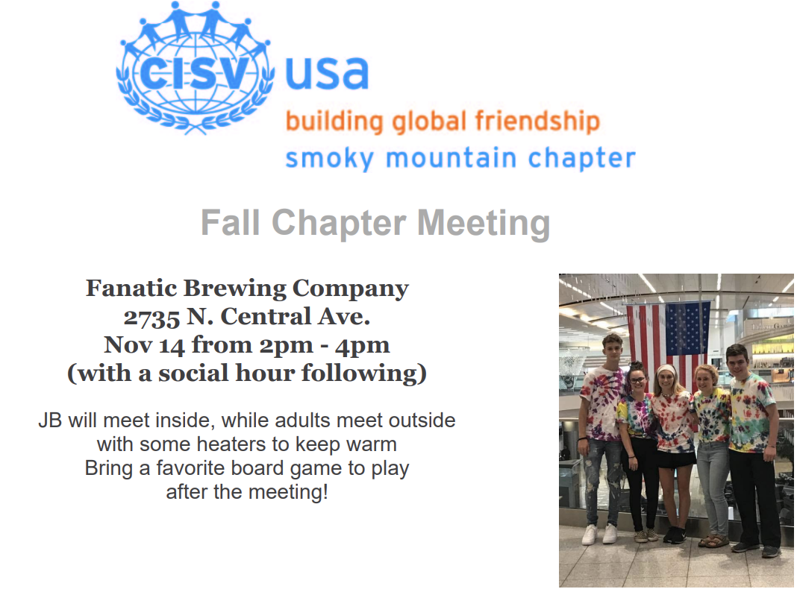

List of Attendees:

Nicole Underwood

Lynne Farmer

Julie Jones

Joe Williams

Sarah